ICT SBA

Leo Wu



Contents

1. Introduction 3

2. Design and Implementation 4

2.1. Design 4

2.2. Navigation Structure 5

2.3. Layout Design 7

2.4. Game Design 9

2.5. Other Design Consideration 9

2.6. Implementation 11

2.7. System Operation 23

2.8. Folder Structure 25

2.9. Description of Important Function 27

3. Reference 30

3.1. Copyright issues 30

3.2. Proposed Working Schedule 31

# Introduction

This is a learning website for kindergarten students to discover the world of music and unlock the magic of melodies and instruments through engaging and interactive lessons designed specifically for kindergarten learners. Our website combines the joy of learning with the power of music to create a fun and educational experience for children. We also provide a tailor-made platform for their parents to monitor their learning progress which enables personalized support and ensures a well-rounded learning experience. Moreover, our website allows teachers to follow up with students’ learning progress comprehensively and distribute tasks to them. This website provides consistence learning functions aimed for stimulating students’ musical talents, including multimedia learning, interactive games, test and exercises.

# Design and Implementation

## Design

* Guest page: Before users login to their account, they visit our guest page that shows our vision statement and what their kids can learn in our website. There is a sitemap at the website that allow them to easily navigate to our learning resources. Also we designed a carousel showing different image of some musical instruments.
* Teacher version: Teachers can sign in their accounts to track their students’ learning progress including when did they complete lessons and quiz. Also, teachers can post messages or tasks to their students by using the Announcement function.
* Parent version: Parents can sign in their accounts to see their children’s information and their learning progress. Parents can also provide their suggestions by completing a form.
* Student version: As the learning website is provided for kindergarten students which are aged young, Our student version website is designed in a more colorful and attractive way that allows them to learn more engagingly. We designed a navigation menu with a suitable pull-down menu to make it easier to locate their desired lessons or games. They can also link to desired webpages by clicking the image directly.
* Functions Provided:

Learning Contents:

Short learning video and audio, Image map, flip card game, drag-n-drop game, solfege listening is provided for students to learn and evaluate themselves in order to recognize the musical instruments and solfege. Also, a metronome is added for them to learn the beats.

Assessments and Feedback:

Multiple choice exercises and matching quizzes are provided for students’ evaluation based on their music knowledge. They can do such exercises repeatedly. After finishing an exercise, immediate feedback will be given to students based on their performance on the exercises. Students can check their weaknesses on the specific topic, then they can revise the learning contents again to consolidate their knowledge, forming a learning cycle.

Communication:

Suggestion form is provided for users to leave their messages to our website. We will gather all the suggestions from them to improve our website in order to provide the most satisfying learning experience for students.

Announcement board is implemented for teacher version. Teachers can announce new tasks for students based on their learning progress.

Login system:

We designed login system for students, teachers, and parents to sign in their accounts to check learning progress.

Accessibility:

We designed site map for physically disabled people to use full keyboard control to access the whole website.

## Navigation Structure

## Layout Design

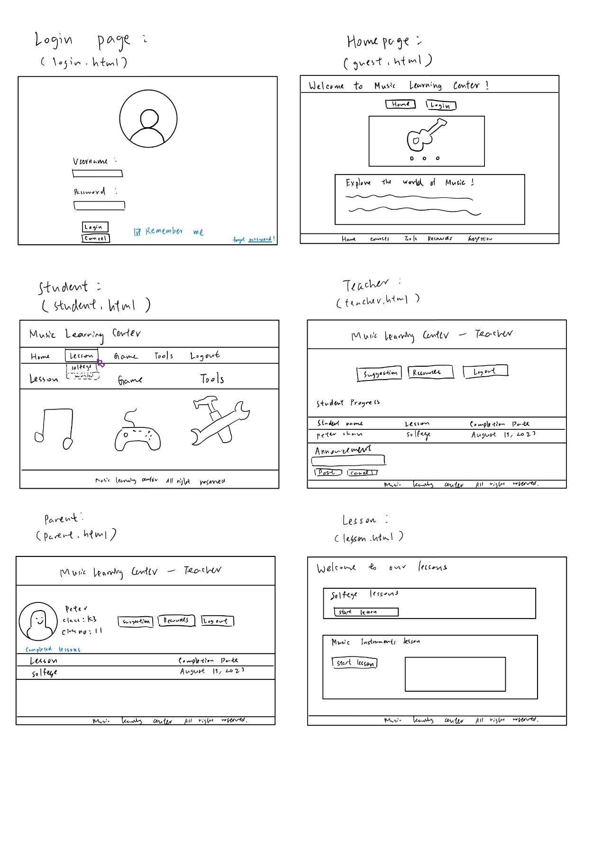

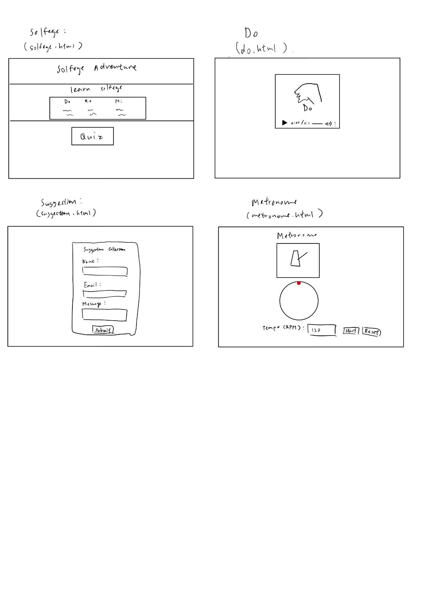

## Game Design

.

## Other Design Consideration

* **Color Scheme:**

Our website for kindergarten students is designed with a vibrant and captivating color scheme that aims to create a visually stimulating and engaging experience for our kindergarten students.

* **Responsive Design:**

Our website uses responsive web design according to the user’s device. It is mobile-user friendly as the size of buttons and images will be changed automatically when users are using portable devices to access our website in order to suit the different screen sizes.

* **User Interface Design:**

We designed 3 different user interfaces for students, teachers and parents. When they login to their own accounts, websites using corresponding user interface design will be opened.

## Implementation

* **Carousel:**

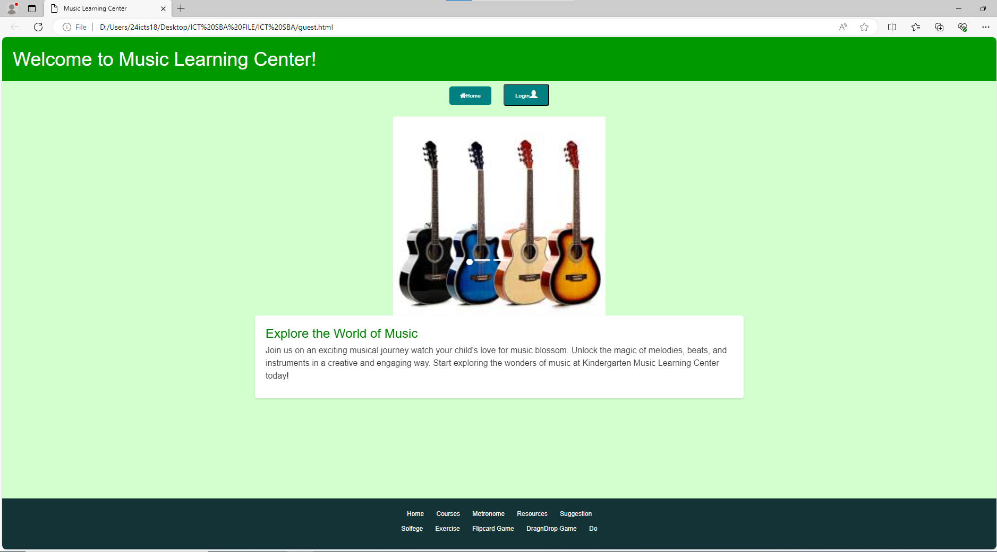

The image in the carousel will change automatically according to time

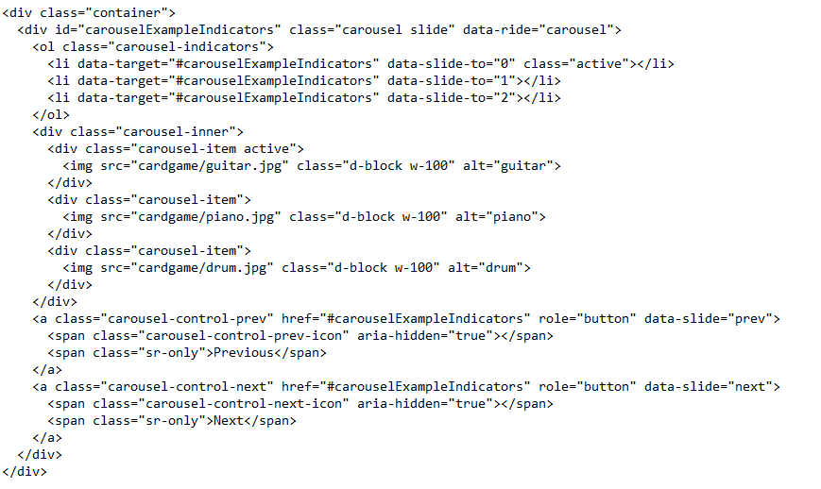

The above code is used to control the carousel

* 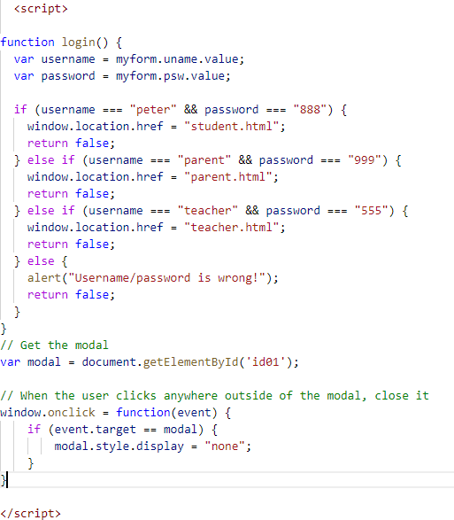**Login function**: CSS and Client-side scripts are used to simulate the login function. Data validation is also done to ensure validated username and password. When the users enter correct username and password, they can login to the corresponding accounts (Students, Parents, Teacher)

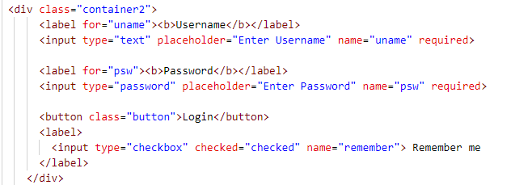

* **Interface Design**:

Guest Page: In this page, our users can click the login button to sign in their accounts. We designed a carousel to show some basic musical instruments on our website.

**Responsive web design:**

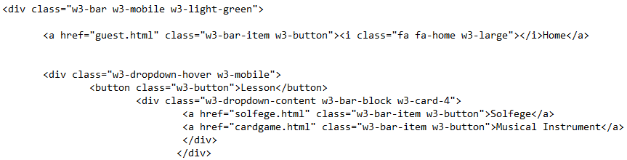

**Desktop version:**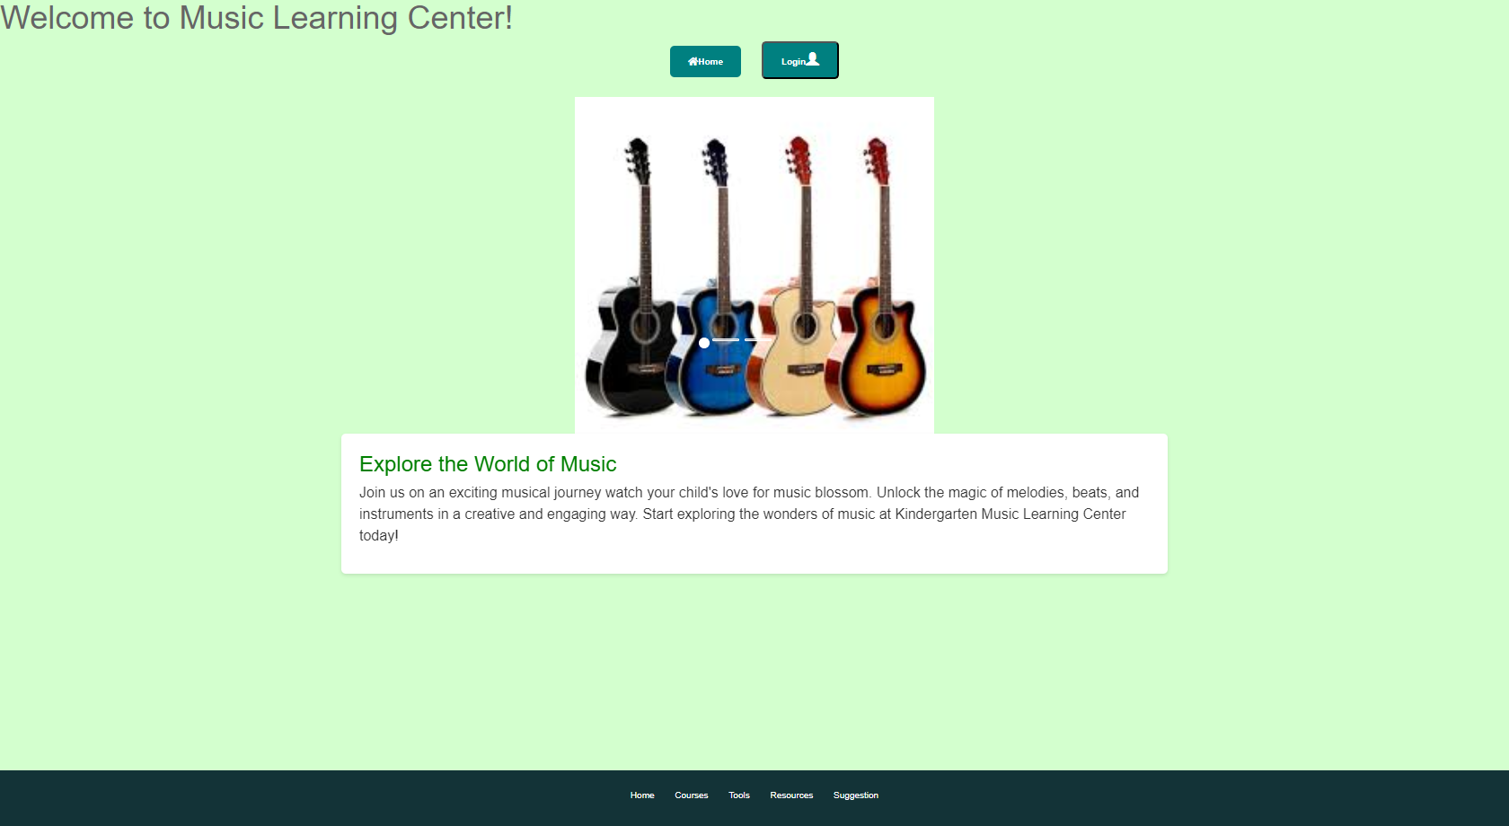

**Mobile version:**

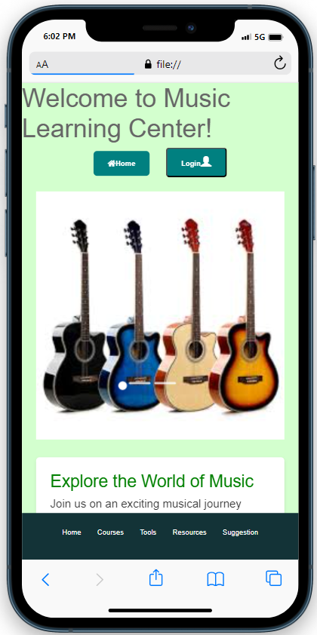

When users are using their mobile device to access our website, The size of buttons and images will be changed in order to suit the different screen sizes by using the style(width=”100%”)

Student page: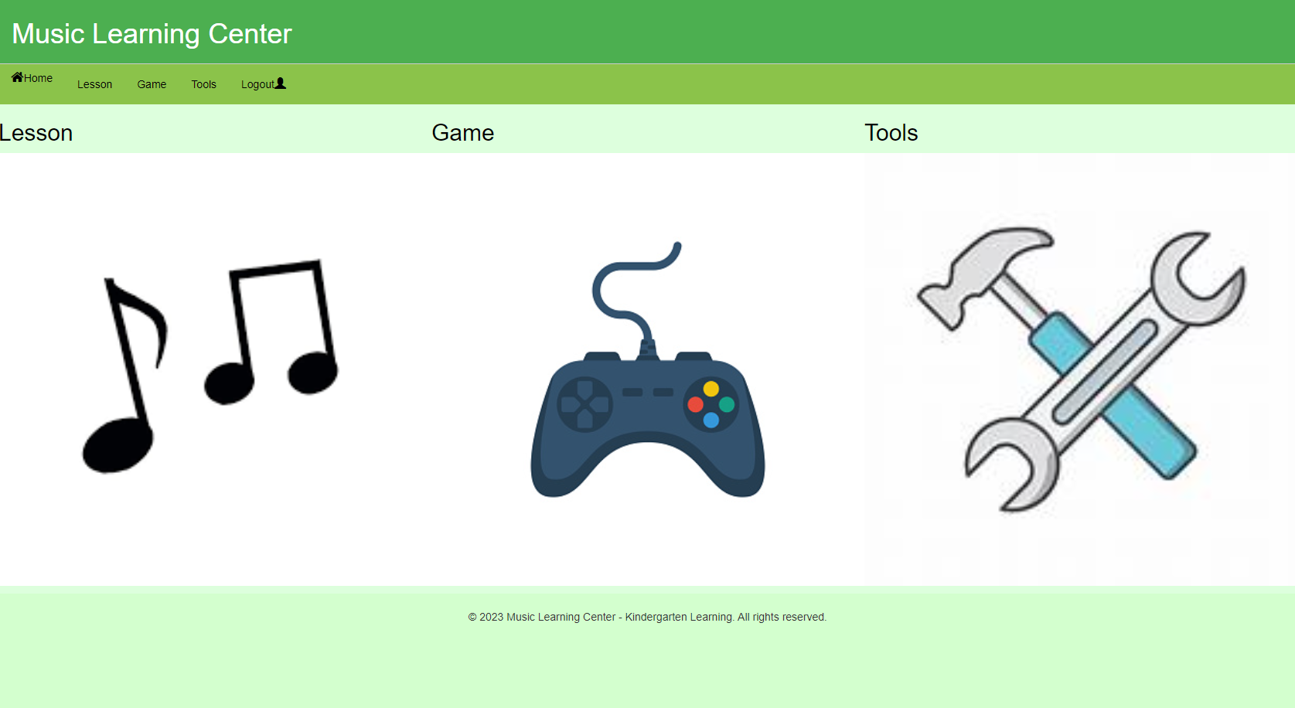

In the Student learning website, we designed to show different learning pages in two ways: Use the navigation menu with pull down menu or click the corresponding images to that direct to different pages

This page includes Solfege and Musical Instrument lessons from our website, with a short learning video for students to get the basic concept of music performance, thus increasing their willingness to learn music.

The code of the video implementation:

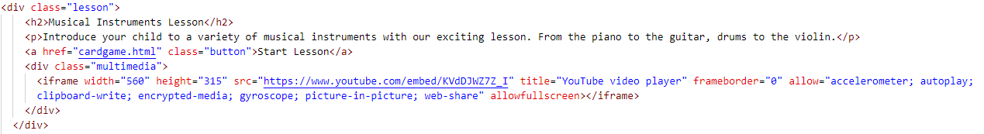

The <iframe> tag is used to include the learning video

* **Learning Function**

Image map:

Image map is implemented in our Solfege lesson. When students click the defined area of the image, it will link to corresponding pages.

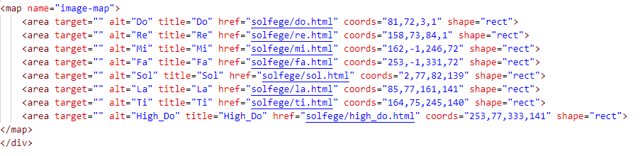

Using appropriate audio can make learning more interesting, Students will learn more engagingly. We also want to increase the consistency of the learning website by adding suitable images.

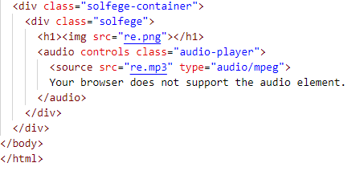 The code of audio implementation:

The <audio> tag is used to play the audio.

* Game functions

Flip card game:

(Before Flipping)

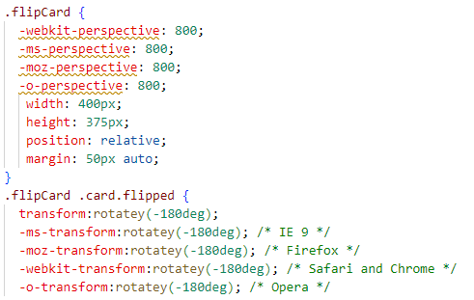The code of the flip card function:

After Clicking the image of the card, the card will flip itself.

Students can drag the image of the card to the corresponding box of the musical instruments.

|  |  |
| --- | --- |
| When they drag the card correctly,  One mark will be counted and shown  on the top of the page. | When all cards are dragged to the correct boxes,  The website will send a congratulation message to the student. |

We also designed a multiple-choice quiz for students to evaluate their learning progress after finishing the lessons.

Feeback will be given to students immediately when they finish the quiz.

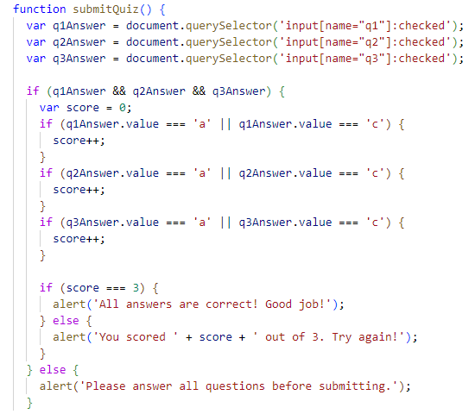

## System Operation

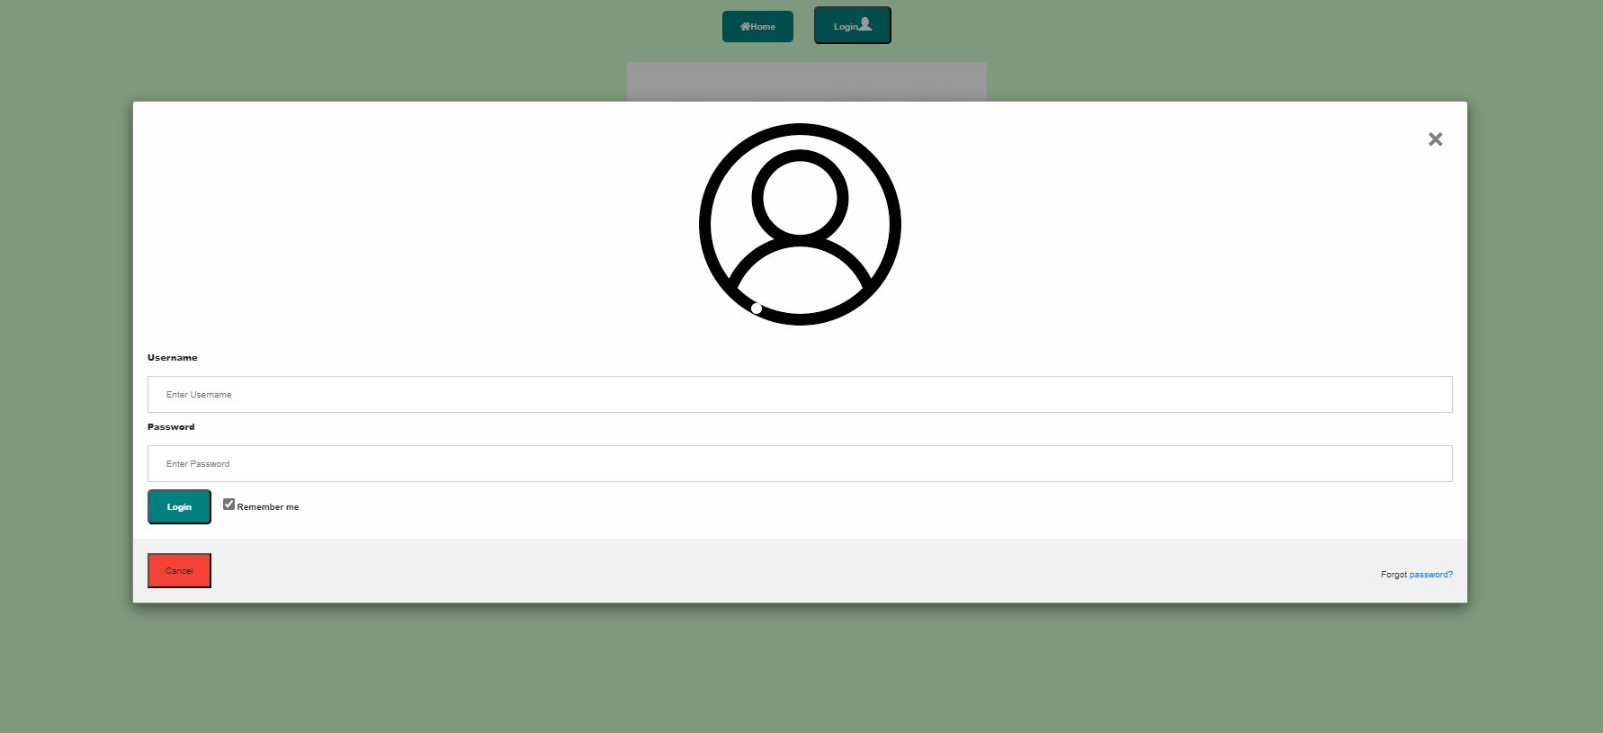Users have to login their account first:

Step 3:

Click button “Login”

Step 2:

Input password

Step 1:

Input username

**Student**

Username: peter

Password: 888

**Parent**

Username: parent

Password: 999

**Teacher**

Username: teacher

Password: 555

Different accounts will be directed to different webpage

**Steps of using the metronome:**

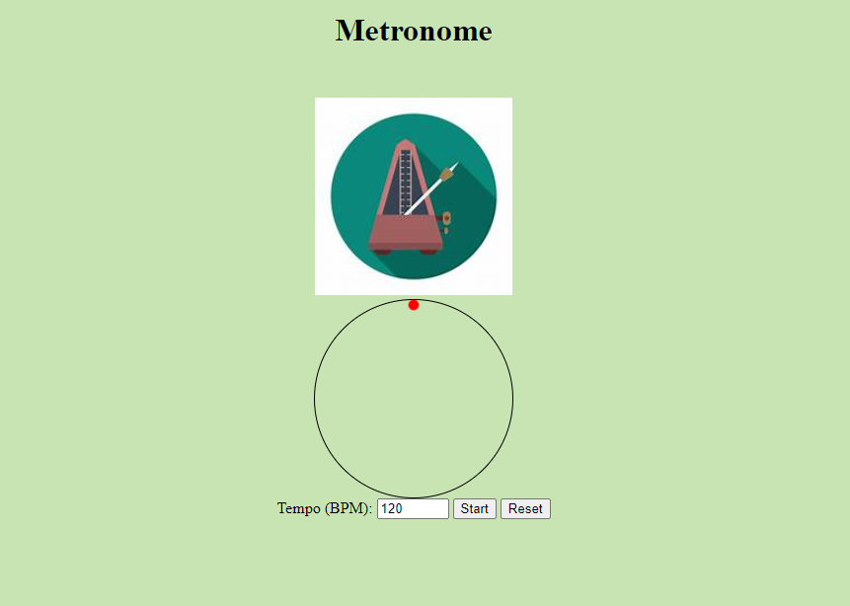

Step3: click the reset button when to stop

Step2: click the start button

Step1: type in the value of bpm

Announcement function:

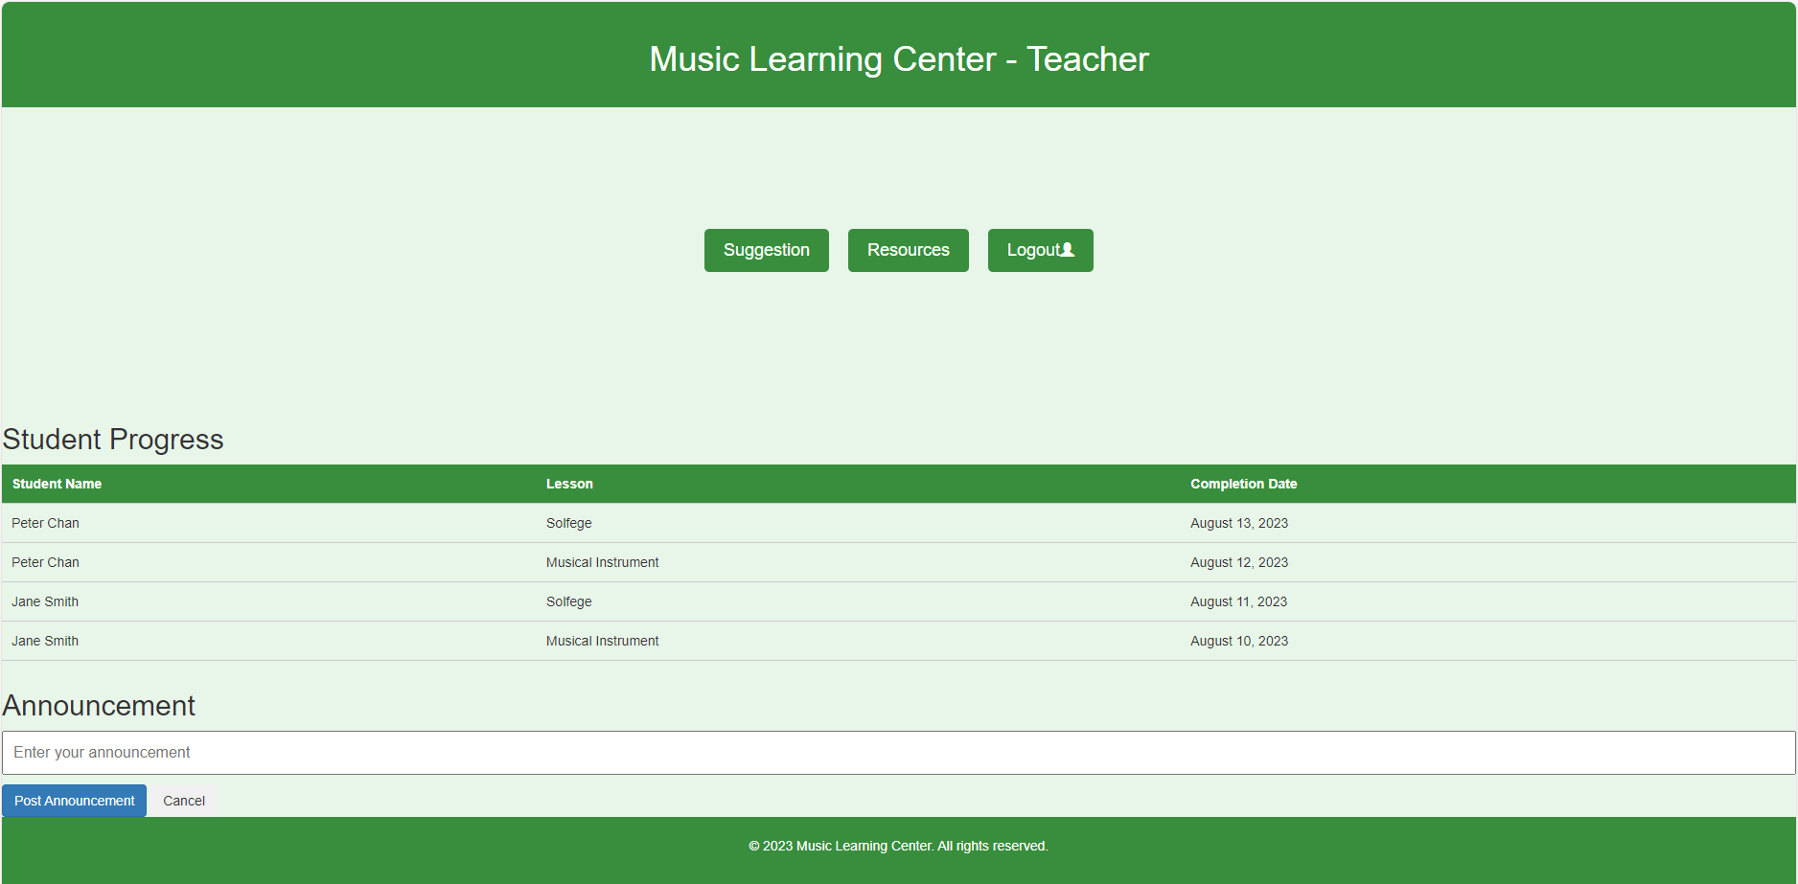

Step1: type the message in text box

Step2: click the post button to deliver the message

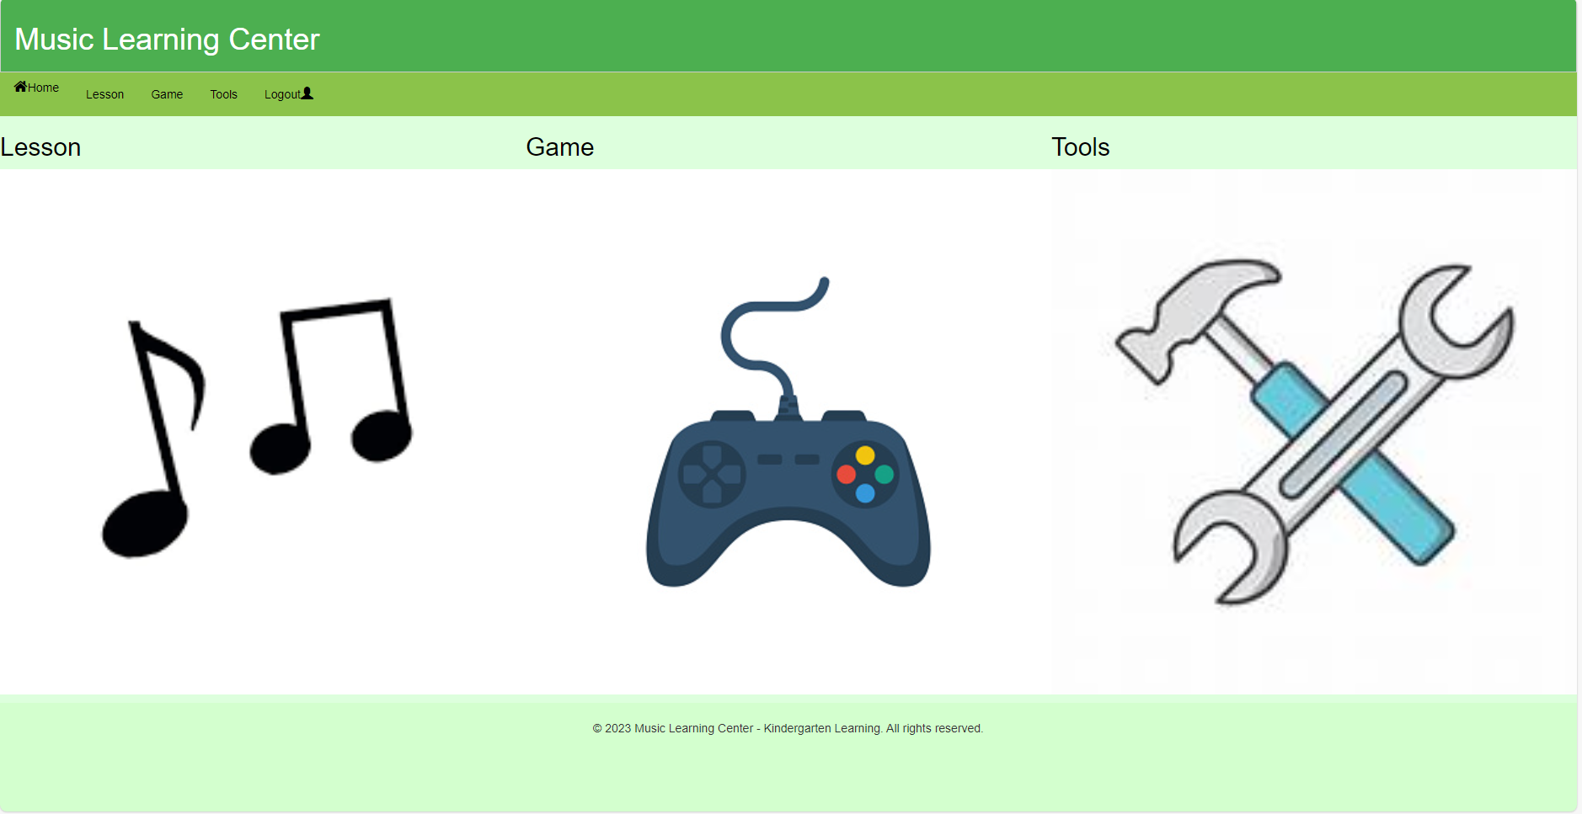

Students should click the image to navigate to lesson page or game page

**Drag-n-drop game:**

Students should drag the piano image into piano box to get one score

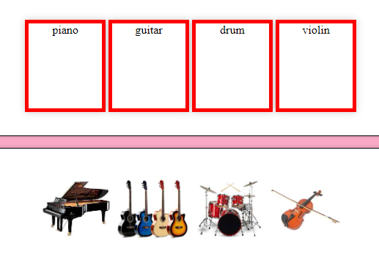

## Folder Structure

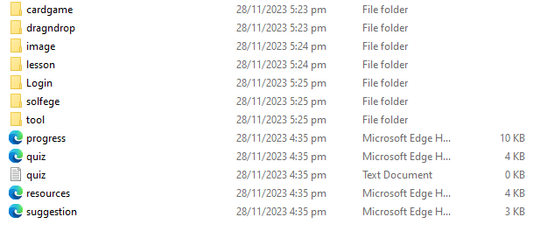

## Description of Important Function

**Image map:**

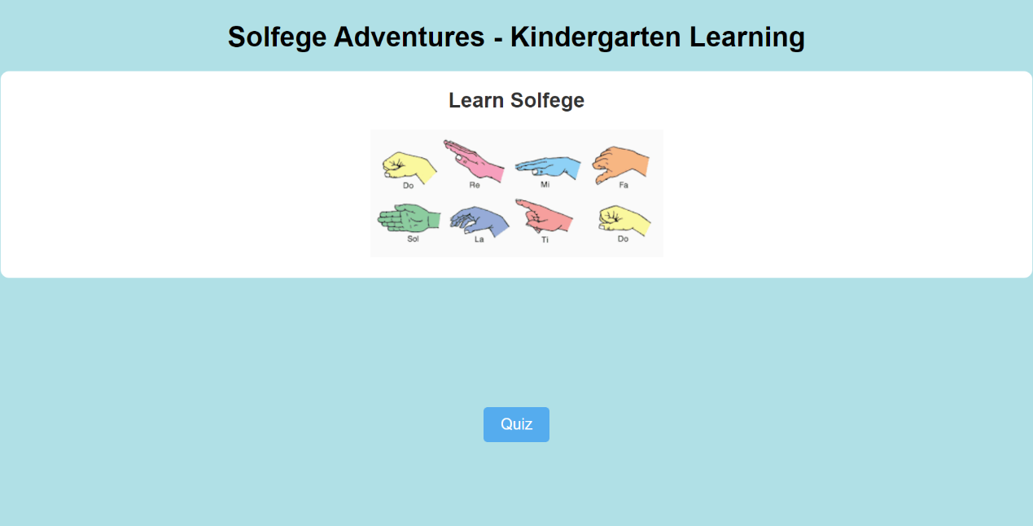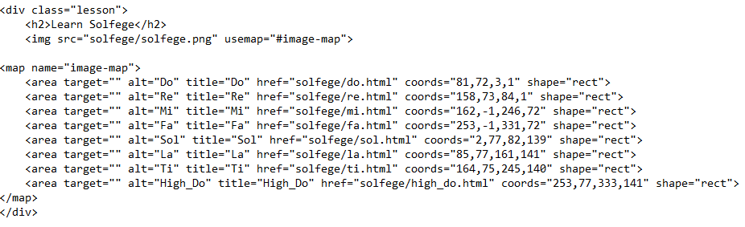The solfege lesson page is designed using image map attribute, when the defined are is clicked, it directs to the corresponding page.

**Progress checking:**

For teachers:

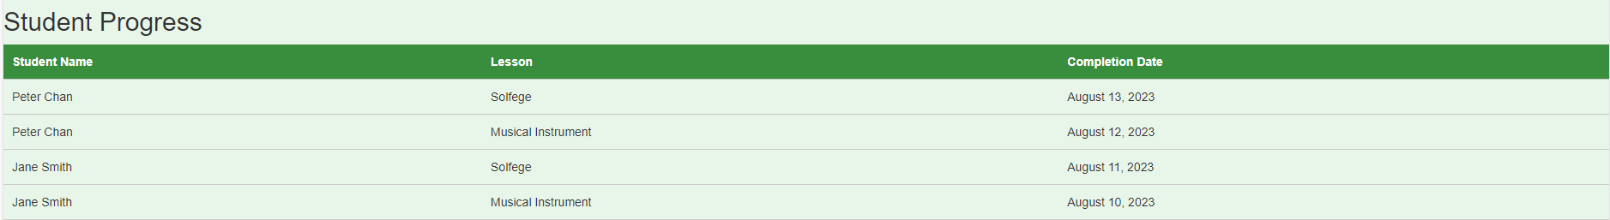When students have completed the lessons, the record will be sent to the server to update the record. Then the record will be sent to teacher’s account

For parents:

When their children have completed the lesson, the record will also be sent to parents

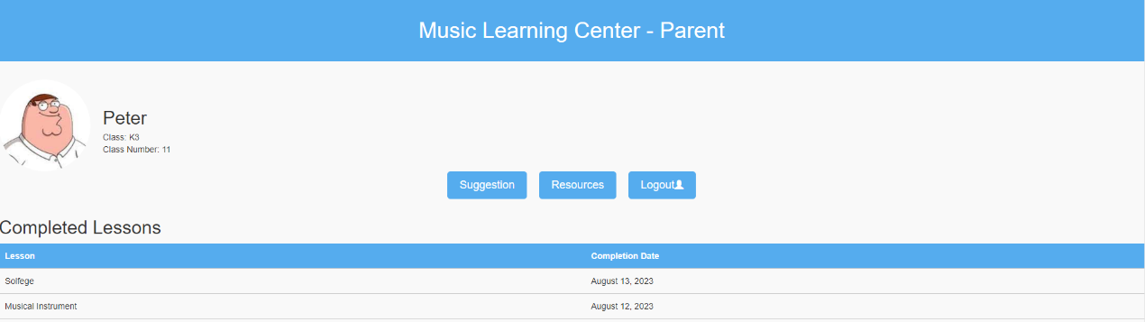

**Sitemap:**

Sitemap is designed such that users can use full-keyboard control to access our website by using “tab” and “enter” key, especially for the physically disabled people.

# Reference

## Copyright issues

The following email is sent to the copyright owner of our website resources to get the permission of using their pictures for educational purpose.

Dear [Website Owner's Name],

I hope this message finds you well. I am writing to request your permission to use the pictures from your homepage for a personal project.

I am currently a Form 6 student and am in the process of learning how to create my own homepage. During my research, I came across your website and was truly impressed by the beautiful pictures featured on your homepage. They perfectly align with the aesthetic I envision for my own project.

I would be extremely grateful if you could grant me permission to utilize these pictures in my homepage assignment. Please rest assured that the files will only be used for educational purposes and will not be employed for any commercial activities whatsoever.

Thank you for considering my request. I eagerly await your response. Should you require any further information or have any specific conditions regarding the use of the pictures, please do not hesitate to let me know.

Thank you for your time and attention.

Yours faithfully,

Leo Wu

## Proposed Working Schedule



 